1. How can you remove duplicates in an array?
The following program will help you to remove duplicates from an array.
#include <stdio.h>
int main() {
int n, a[100], b[100], calc = 0, i, j,count;
printf("Enter no. of elements in array: ");
scanf("%d", &n);
printf("Enter %d integers: ", n);
for (i = 0; i < n; i++)
scanf("%d", &a[i]);

for (i = 0; i<n; i++) {
for (j = 0; j<calc; j++) {
if(a[i] == b[j])
break;
}
if (j== calc) {
b[calc] = a[i];
calc++;
}
}

printf("Array obtained after removing duplicate elements: ");
for (i = 0; i<calc; i++) {
printf("%d ", b[i]);
}
return 0;
}

2. Can we compile a program without a main() function?
Yes, we can compile a program without main() function Using Macro.
E.g.
#include<studio.h>
#define abc main
int abc ()
{
printf("Hello World ");
return 0;
}

3. Write a program to get the higher and lower nibble of a byte without using shift operator?
#include<stdio.h>
struct full_byte
{
char first : 4;
char second : 4;
};

union A
{
char x;
struct full_byte by;
};

main()
{
char c = 100;
union A a;
a.x = c;
printf("the two nibbles are: %d and %d\n", a.by.first, a.by.second);
}

4. How do you override a defined macro?
To override a defined macro we can use #ifdef and #undef preprocessors as follows:
- #ifdef A
- #undef A
- #endif
- #define A 10
If macro A is defined, it will be undefined using undef and then defined again using define.
5. Write a C program to check if it is a palindrome number or not using a recursive method.(same forward and backward, e.g., 121, 1221, 545)
#include <stdio.h>
#include <conio.h>
int reverse(int num);
int isPalindrome(int num);
int main()
{
int num;
printf("Enter a number: ");
scanf("%d", &num);
if(isPalindrome(num) == 1)
{
printf("the given number is a palindrome");
}
else
{
printf("the given number is not a palindrome number");
}
return 0;
}

int isPalindrome(int num)
{
if(num == reverse(num))
{
return 1;
}
return 0;
}
int reverse(int num)
{
int rem;
static int sum=0;
if(num!=0){
rem=num%10;
sum=sum*10+rem;
reverse(num/10);
}
else
return sum;
return sum;
}

6. C program to check the given number format is in binary or not.
#include<stdio.h>
#include<conio.h>
int main() {
int j,num;
printf("Please enter a number :");
scanf("%d",&num);
while(num>0)
{
j=num%10;
if( j!=0 && j!=1 )
{
printf("num is not binary");
break;
}
num=num/10;
if(num==0)
{
printf("num is binary");
}
}
getch();
}

7. C Program to find a sum of digits of a number using recursion.
#include<stdio.h>
#include<conio.h>

int sumOfDigits(int num)
{
static int sum = 0;
int rem;
sum = sum + (num%10);
rem = num/10;
if(rem > 0)
{
sumOfDigits(rem);
}
return sum;
}
int main() {
int j,num;
printf("Please enter a number :");
scanf("%d",&num);
printf("sum of digits of the number = %d ",sumOfDigits(num));
getch();
}

8. Can you tell me how to check whether a linked list is circular?
Single Linked List
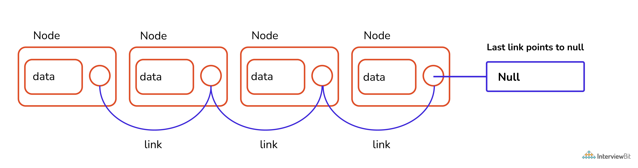Single Linked List
Circular Linked List
Circular linked list is a variation of a linked list where the last node is pointing to the first node's information part. Therefore the last node does not point to null.

Algorithm to find whether the given linked list is circular
A very simple way to determine whether the linked list is circular or not
- Traverse the linked list
- Check if the node is pointing to the head.
- If yes then it is circular.
Let's look at the snippet where we code this algorithm.
Create a structure for a linked list
Declare
-Variable to store data of the node.
-Pointer variable of struct type to store the address of next node.
function of datatype tool isCircular(firstgode){

-Store the value of first node in temp variable and make it traverse all nodes.
-temp-firstgode
-tempenext node pointed by temp(temp->next)
-run until temp is at null or firstNode
if (temp at null)
not circular and returns false if (temp points first node)
return true as its circular.
}

function of datatype node newNode(data){

-To insert new nodes and link each one of them to the previous node by storing the address of the new node to the previous one.
-Then make them point to NULL.
}

In int main function

-First insert nodes for circular linked list and check its nature by calling isCircular function.
-Since it is true through if statement it prints "yes..
-Second insert a normal linked list and check its nature by calling isCircular function. As its not circular it prints "no",

9. What is the use of a semicolon (;) at the end of every program statement?
It is majorly related to how the compiler reads( or parses) the entire code and breaks it into a set of instructions(or statements), to which semicolon in C acts as a boundary between two sets of instructions.

10. How to call a function before main()?
To call a function before the main(), pragma startup directive should be used. E.g.-
#pragma startup fun
void fun()
{
printf("In fun\n");
}
main()
{
printf("In main\n");
}
The output of the above program will be -
In fun
In main
This pragma directive, on the other hand, is compiler-dependent. This is not supported by gcc. As a result, it will ignore the startup directive and produce no error. But the output, in that case, will be -
In main

11. Differentiate between the macros and the functions.
The differences between macros and functions can be explained as follows:
Macros | Functions
It is preprocessed rather than compiled. | It is compiled not preprocessed.
It is preprocessed rather than compiled. | Function checks for compilation errors.
Code length is increased. | Code length remains the same.
Macros are faster in execution. | Functions are a bit slower in execution.
Macros are useful when a small piece of code is used multiple times in a program. | Functions are helpful when a large piece of code is repeated a number of times.

12. Differentiate Source Codes from Object Codes
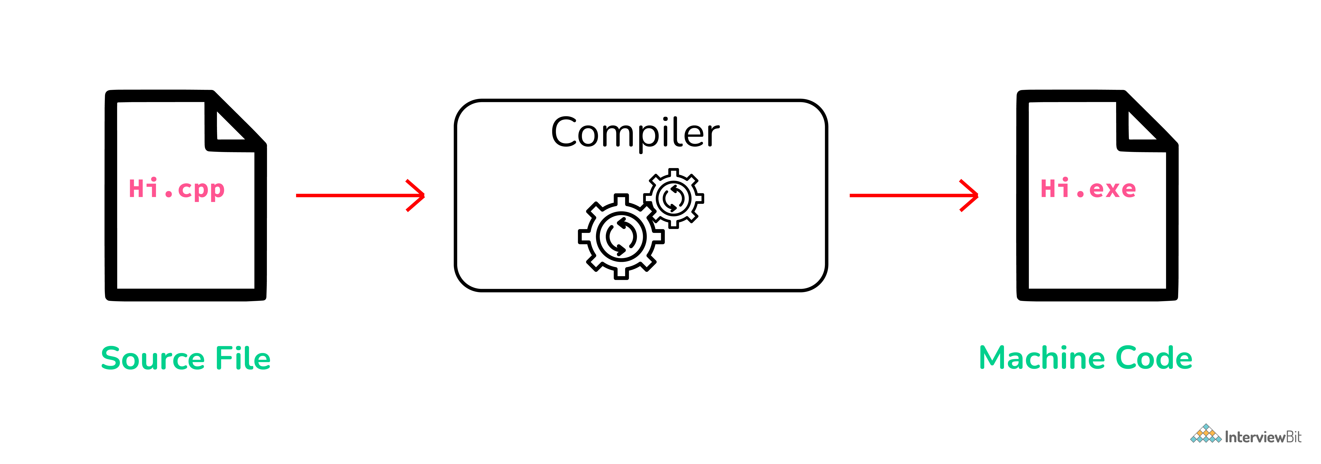Source Code and Object Code Difference
The difference between the Source Code and Object Code is that Source Code is a collection of computer instructions written using a human-readable programming language while Object Code is a sequence of statements in machine language, and is the output after the compiler or an assembler converts the Source Code.
The last point about Object Code is the way the changes are reflected. When the Source Code is modified, each time the Source Code needs to be compiled to reflect the changes in the Object Code.

13. What are header files and what are its uses in C programming?
Header Files in C
In C header files must have the extension as .h, which contains function definitions, data type definitions, macro, etc. The header is useful to import the above definitions to the source code using the #include directive. For example, if your source code needs to take input from the user do some manipulation and print the output on the terminal, it should have stdio.h file included as #include <stdio.h>, with which we can take input using scanf() do some manipulation and print using printf().

14. When is the "void" keyword used in a function
The keyword “void” is a data type that literally represents no data at all. The most obvious use of this is a function that returns nothing:
void PrintHello() {
printf("Hello\n");
return; // the function does "return", but no value is returned
}
Here we’ve declared a function, and all functions have a return type. In this case, we’ve said the return type is “void”, and that means, “no data at all” is returned.
The other use for the void keyword is a void pointer. A void pointer points to the memory location where the data type is undefined at the time of variable definition. Even you can define a function of return type void* or void pointer meaning “at compile time we don’t know what it will return” Let’s see an example of that.
void MyMemCopy(void* dst, const void* src, int numBytes) {
char* dst_c = reinterpret_cast<char*>(dst);
const char* src_c = reinterpret_cast<const char*>(src);
for (int i = 0; i < numBytes; ++i)
dst_c[i] = src_c[i];
}

15. What is dynamic data structure?
A dynamic data structure (DDS) refers to an organization or collection of data in memory that has the flexibility to grow or shrink in size, enabling a programmer to control exactly how much memory is utilized. Dynamic data structures change in size by having unused memory allocated or de-allocated from the heap as needed.
Dynamic data structures play a key role in programming languages like C, C++, and Java because they provide the programmer with the flexibility to adjust the memory consumption of software programs.

16. Add Two Numbers Without Using the Addition Operator
For the sum of two numbers, we use the addition (+) operator. In these tricky C programs, we will write a C program to add two numbers without using the addition operator.
#include<stdio.h>#include<stdlib.h>int main(){
int x, y;
printf("Enter two number: ");
scanf("%d %d",&x,&y);

// method 1
printf("%d\n", x-(-y));

// method 2
printf("%d\n", -(-x-y));

// method 3
printf("%d\n", abs(-x-y));

// method 4
printf("%d", x-(~y)-1);

return 0;
}

17. Subtract Two Number Without Using Subtraction Operator
#include<stdio.h>#include<stdlib.h>int main(){
int x, y;
printf("Enter two number: ");
scanf("%d %d",&x,&y);
printf("%d", x+(~y)+1);
return 0;
}
The bitwise complement operator is used in this program. The bitwise complement of number ~y=-(y+1). So, expression will become x+(-(y+1))+1=x-y-1+1=x-y

18. Multiply an Integer Number by 2 Without Using Multiplication Operator
#include<stdio.h>int main(){
int x;
printf("Enter a number: ");
scanf("%d",&x);
printf("%d", x<<1);
return 0;
}
The left shift operator shifts all bits towards the left by a certain number of specified bits. The expression x<<1 always returns x*2. Note that the shift operator doesn’t work on floating-point values.
For multiple of x by 4, use x<<2. Similarly x<<3 multiply x by 8. For multiple of the number x by 2^n, use x<<n.

19. Check whether the number is EVEN or ODD, without using any arithmetic or relational operators
#include<stdio.h>int main(){
int x;
printf("Enter a number: ");
scanf("%d", &x);
(x&1)?printf("Odd"):printf("Even");
return 0;
}
The bitwise and(&) operator can be used to quickly check the number is odd or even.

20. Reverse the Linked List. Input: 1->2->3->4->5->NULL Output: 5->4->3->2->1->NULL
Assume that we have linked list 1 → 2 → 3 → Ø, we would like to change it to Ø ← 1 ← 2 ← 3.

While you travel the linked list, change the current node's next pointer to point to its previous element. reference to the previous nodes should be stored into a temp variable as shown so that we don’t lose track of the swapped node. You also need another pointer to store the next node before changing the reference. Also when we are done return the new head of the reversed list.
/* Function to reverse the linked list */static void reverse(struct Node** head_ref) {
struct Node* prev = NULL;
struct Node* current = *head_ref;
struct Node* next;
while (current != NULL)
{
// store next
next = current->next;

// reverse curr node pointer
current->next = prev;

// move pointer one position ahead
prev = current;
current = next;
}
*head_ref = prev;
}

21. Check for Balanced Parentheses using Stack
Given a string s containing just the characters '(', ')', '{', '}', '[' and ']', determine if the input string is valid.
An input string is valid if:
- Open brackets must be closed by the same type of brackets.
- Open brackets must be closed in the correct order.
Example 1:
Input: s = "()"
Output: true
Example 2:
Input: s = "()[]{}"
Output: true
Example 3:
Input: s = "(]"
Output: false

Below is the source code for C Program to Check for Balanced Parentheses using Stack which is successfully compiled and run on Windows System to produce desired output as shown below :
int check(char exp[] ){
int i;
char temp;
for(i=0;i<strlen(exp);i++)
{
if(exp[i]=='(' || exp[i]=='{' || exp[i]=='[')
push(exp[i]);
if(exp[i]==')' || exp[i]=='}' || exp[i]==']')
if(top==-1) /*stack empty*/
{
printf("Right parentheses are more than left parentheses\n");
return 0;
}
else
{
temp=pop();
if(!match(temp, exp[i]))
{
printf("Mismatched parentheses are : ");
printf("%c and %c\n",temp,exp[i]);
return 0;
}
}
}
if(top==-1) /*stack empty*/
{
printf("Balanced Parentheses\n");
return 1;
}
else
{
printf("Left parentheses more than right parentheses\n");
return 0;
}
}
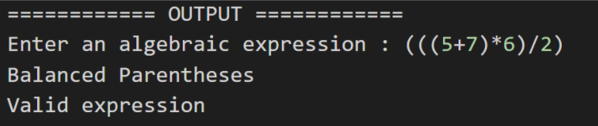

22. Program to find n’th Fibonacci number
Fibonacci sequence is characterized by the fact that every number after the first two is the sum of the two preceding ones. For example, consider below sequence
0, 1, 1, 2, 3, 5, 8, 13, 21, 34, . .. and so on
Where in F{n} = F{n-1} + F{n-2} with base values F(0) = 0 and <code>F(1) = 1
Below is naive implementation for finding the nth member of the Fibonacci sequence
// Function to find the nth Fibonacci numberint fib(int n){
if (n <= 1) {
return n;
}

return fib(n - 1) + fib(n - 2);
}
int main(){
int n = 8;

printf("nth Fibonacci number is %d", fib(8));

return 0;
}

23. Write a program to find the node at which the intersection of two singly linked lists begins.
Let's take an example of the following two linked lists which intersect at node c1.
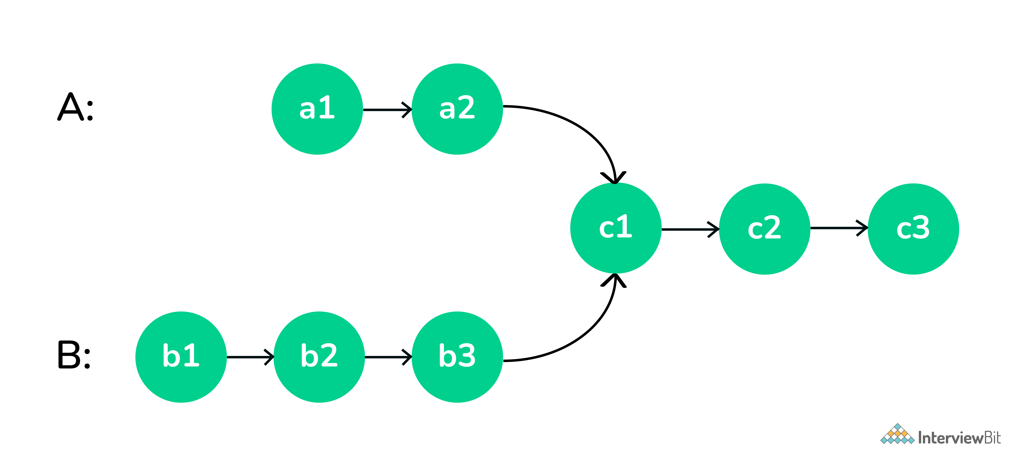Intersection of Two Linked List
Solution -
- Get count of the nodes in the first list, let count be c1.
- Get count of the nodes in the second list, let count be c2.
- Get the difference of counts d = abs(c1 – c2)
- Now traverse the bigger list from the first node till d nodes so that from here onwards both the lists have an equal no of nodes
- Then we can traverse both the lists in parallel till we come across a common node. (Note that getting a common node is done by comparing the address of the nodes)
// Function to get the intersection point // of the given linked lists int getIntersectionNode(Node* head1, Node* head2) {
Node *curr1 = head1, *curr2 = head2;

// While both the pointers are not equal
while (curr1 != curr2) {

// If the first pointer is null then
// set it to point to the head of
// the second linked list
if (curr1 == NULL) {
curr1 = head2;
}

// Else point it to the next node
else {
curr1 = curr1->next;
}

// If the second pointer is null then
// set it to point to the head of
// the first linked list
if (curr2 == NULL) {
curr2 = head1;
}

// Else point it to the next node
else {
curr2 = curr2->next;
}
}

// Return the intersection node
return curr1->data;
}

24. Merge Two sorted Linked List
Merge two sorted linked lists and return them as a sorted list. The list should be made by splicing together the nodes of the first two lists.
Merging Two Sorted Linked List
NodePtr merge_sorted(NodePtr head1, NodePtr head2) {

// if both lists are empty then merged list is also empty
// if one of the lists is empty then other is the merged list
if (head1 == nullptr) {
return head2;
} else if (head2 == nullptr) {
return head1;
}

NodePtr mergedHead = nullptr;
if (head1->data <= head2->data) {
mergedHead = head1;
head1 = head1->next;
} else {
mergedHead = head2;
head2 = head2->next;
}

NodePtr mergedTail = mergedHead;

while (head1 != nullptr && head2 != nullptr) {
NodePtr temp = nullptr;
if (head1->data <= head2->data) {
temp = head1;
head1 = head1->next;
} else {
temp = head2;
head2 = head2->next;
}

mergedTail->next = temp;
mergedTail = temp;
}

if (head1 != nullptr) {
mergedTail->next = head1;
} else if (head2 != nullptr) {
mergedTail->next = head2;
}

return mergedHead;
}
Runtime Complexity Linear, O(m + n) where m and n are lengths of both linked lists.
Memory Complexity Constant, O(1)
Maintain a head and a tail pointer on the merged linked list. Then choose the head of the merged linked list by comparing the first node of both linked lists. For all subsequent nodes in both lists, you choose the smaller current node and link it to the tail of the merged list, moving the current pointer of that list one step forward.
You keep doing this while there are some remaining elements in both lists. If there are still some elements in only one of the lists, you link this remaining list to the tail of the merged list.
Initially, the merged linked list is NULL. Compare the value of the first two nodes and make the node with the smaller value the head node of the merged linked list. In this example, it is 4 from head1.

C Intermediate Interview Questions

1. Specify different types of decision control statements?
All statements written in a program are executed from top to bottom one by one. Control statements are used to execute/transfer the control from one part of the program to another depending on the condition.
- If-else statement.
  - normal if-else statement.
  - Else-if statement
  - nested if-else statement.
- Switch statement.

2. What is an r-value and l-value?
- The term "r-value" refers to a data value stored in memory at a given address. An r-value is an expression that cannot have a value assigned to it, hence it can only exist on the right side of an assignment operator(=).
- The term "l-value" refers to a memory location that is used to identify an object. The l-value can be found on either the left or right side of an assignment operator(=). l-value is frequently used as an identifier.

3. What is the difference between malloc() and calloc()?
calloc() and malloc() are memory dynamic memory allocating functions. The main difference is that malloc() only takes one argument, which is the number of bytes, but calloc() takes two arguments, which are the number of blocks and the size of each block.

4. What is the difference between struct and union in C?
A struct is a group of complex data structures stored in a block of memory where each member on the block gets a separate memory location to make them accessible at once
Whereas in the union, all the member variables are stored at the same location on the memory as a result to which while assigning a value to a member variable will change the value of all other members.
/* struct & union definations*/struct bar {
int a; // we can use a & b both simultaneously
char b;
} bar;
union foo {
int a; // we can't use both a and b simultaneously
char b;
} foo;
/* using struc and union variables*/
struct bar y;
y.a = 3; // OK to use
y.b = 'c'; // OK to use
union foo x;
x.a = 3; // OK
x.b = 'c'; // NOl this affects the value of x.a!

5. What is call by reference in functions?
When we caller function makes a function call bypassing the addresses of actual parameters being passed, then this is called call by reference. In incall by reference, the operation performed on formal parameters affects the value of actual parameters because all the operations performed on the value stored in the address of actual parameters.

6. What is pass by reference in functions?
In Pass by reference, the callee receives the address and makes a copy of the address of an argument into the formal parameter. Callee function uses the address to access the actual argument (to do some manipulation). If the callee function changes the value addressed at the passed address it will be visible to the caller function as well.
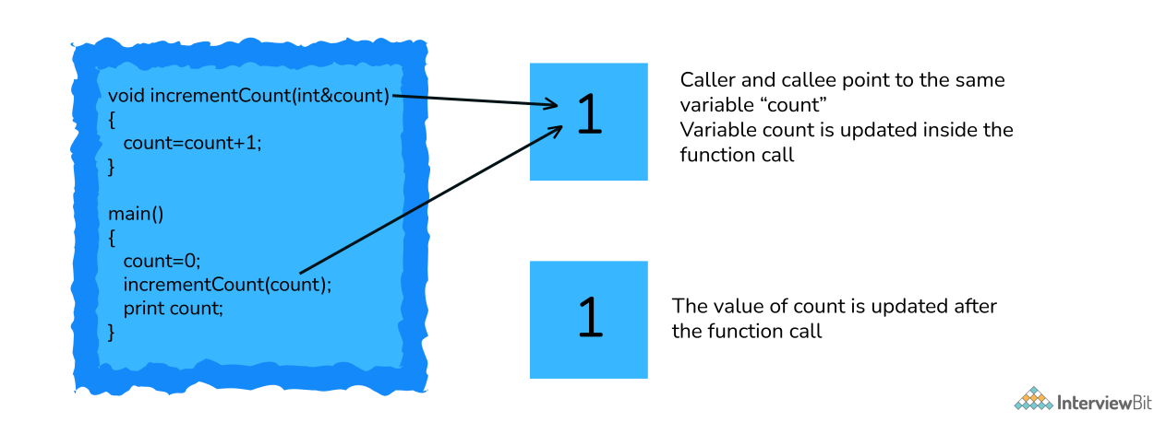Pass By Reference

7. What is a memory leak? How to avoid it?
When we assign a variable it takes space of our RAM (either heap or RAM)dependent on the size of data type, however, if a programmer uses a memory available on the heap and forgets to a delta it, at some point all the memory available on the ram will be occupied with no memory left this can lead to a memory leak.
int main(){
char * ptr = malloc(sizeof(int));

/* Do some work */
/*Not freeing the allocated memory*/
return 0;
}
To avoid memory leaks, you can trace all your memory allocations and think forward, where you want to destroy (in a good sense) that memory and place delete there. Another way is to use C++ smart pointer in C linking it to GNU compilers.

8. What is Dynamic memory allocation in C? Name the dynamic allocation functions.
C is a language known for its low-level control over the memory allocation of variables in DMA there are two major standard library malloc() and free. The malloc() function takes a single input parameter which tells the size of the memory requested It returns a pointer to the allocated memory. If the allocation fails, it returns NULL. The prototype for the standard library function is like this:
void *malloc(size_t size);
The free() function takes the pointer returned by malloc() and de-allocates the memory. No indication of success or failure is returned. The function prototype is like this:
void free(void *pointer);
There are 4 library functions provided by C defined under <stdlib.h> header file to facilitate dynamic memory allocation in C programming. They are:
- malloc()
- calloc()
- free()
- realloc()

9. What is typedef?
typedef is a C keyword, used to define alias/synonyms for an existing type in C language. In most cases, we use typedef's to simplify the existing type declaration syntax. Or to provide specific descriptive names to a type.
typedef <existing-type> <new-type-identifiers>;
typedef provides an alias name to the existing complex type definition. With typedef, you can simply create an alias for any type. Whether it is a simple integer to complex function pointer or structure declaration, typedef will shorten your code.

10. Why is it usually a bad idea to use gets()? Suggest a workaround.
The standard input library gets() reads user input till it encounters a new line character. However, it does not check on the size of the variable being provided by the user is under the maximum size of the data type which makes the system vulnerable to buffer overflow and the input being written into memory where it isn’t supposed to.
We, therefore, use gets() to achieve the same with a restricted range of input
Bonus: It remained an official part of the language up to the 1999 ISO C standard, but it was officially removed by the 2011 standard. Most C implementations still support it, but at least GCC issues a warning for any code that uses it.

11. What is the difference between #include "..." and #include <...>?
In practice, the difference is in the location where the preprocessor searches for the included file.
For #include <filename> the C preprocessor looks for the filename in the predefined list of system directories first and then to the directories told by the user(we can use -I option to add directories to the mentioned predefined list).
For #include "filename" the preprocessor searches first in the same directory as the file containing the directive, and then follows the search path used for the #include <filename> form. This method is normally used to include programmer-defined header files.

12. What are dangling pointers? How are dangling pointers different from memory leaks?
The dangling pointer points to a memory that has already been freed. The storage is no longer allocated. Trying to access it might cause a Segmentation fault. A common way to end up with a dangling pointer:
#include<stdio.h>
#include<string.h>
char *func(){
char str[10];
strcpy(str,"Hello!");
return(str);
}
You are returning an address that was a local variable, which would have gone out of scope by the time control was returned to the calling function. (Undefined behavior)
*c = malloc(sizeof(int));free(c);
*c = 3; //writing to freed location!
In the figure shown above writing to a memory that has been freed is an example of the dangling pointer, which makes the program crash.
A memory leak is something where the memory allocated is not freed which causes the program to use an undefined amount of memory from the ram making it unavailable for every other running program(or daemon) which causes the programs to crash. There are various tools like O profile testing which is useful to detect memory leaks on your programs.
void function(){
char *leak = malloc (10); //leak assigned but not freed
}

13. What is the difference between ‘g’ and “g” in C?
In C double-quotes variables are identified as a string whereas single-quoted variables are identified as the character. Another major difference being the string (double-quoted) variables end with a null terminator that makes it a 2 character array.

14. Which is better #define or enum?
- If we let it, the compiler can build enum values automatically. However, each of the defined values must be given separately.
- Because macros are preprocessors, unlike enums, which are compile-time entities, the source code is unaware of these macros. So, if we use a debugger to debug the code, the enum is superior.
- Some compilers will give a warning if we use enum values in a switch and the default case is missing.
- Enum always generates int-type identifiers. The macro, on the other hand, allowed us to pick between various integral types.
- Unlike enum, the macro does not have a defined scope constraint.

15. Suppose a global variable and local variable have the same name. Is it possible to access a global variable from a block where local variables are defined?
No. This isn’t possible in C. It’s always the most local variable that gets preference.

16. Which structure is used to link the program and the operating system?
The file structure is used to link the operating system and a program. The header file "stdio.h" (standard input/output header file) defines the file. It contains information about the file being used like its current size and its memory location. It contains a character pointer that points to the character which is currently being opened. When you open a file, it establishes a link between the program and the operating system about which file is to be accessed.

17. What is a near pointer and a far pointer in C?
- Near Pointer: In general, the near pointer can be considered because it is used to hold the address, which has a maximum size of just 16 bits. We can't store an address with a size larger than 16 bits using the near pointer. All other smaller addresses that are within the 16-bit limit, on the other hand, can be stored. Because we can only access 64kb of data at a time, you might assume the 16 bits are insufficient. As a result, it is regarded as one of the near-pointer's biggest drawbacks, which is why it is no longer commonly used.
- Far Pointer: A far pointer is considered a pointer of size 32 bits. It can, however, use the current segment to access information stored outside the computer's memory. Although, in order to use this type of pointer, we usually need to allocate the sector register to store the data address in the current segment.

C Basic Interview Questions

1. Why is C called a mid-level programming language?
C has characteristics of both assembly-level i.e. low-level and higher-level languages. So as a result, C is commonly called a middle-level language. Using C, a user can write an operating system as well as create a menu-driven consumer billing system.


Create A Free Personalised Study Plan
Get into your dream companies with expert guidance
Real-Life Problems
Prep for Target Roles
Custom Plan Duration
Create My Plan

2. What are the features of the C language?
Some features of the C language are-
- It is Simple And Efficient.
- C language is portable or Machine Independent.
- C is a mid-level Programming Language.
- It is a structured Programming Language.
- It has a function-rich library.
- Dynamic Memory Management.
- C is super fast.
- We can use pointers in C.
- It is extensible.

3. What is a token?
The individual elements of a program are called Tokens. There are following 6 types of tokens are available in C:
- Identifiers
- Keywords
- Constants
- Operators
- Special Characters
- Strings
You can download a PDF version of C Interview Questions.
Download PDF

4. What is the use of printf() and scanf() functions? Also explain format specifiers?
- printf() is used to print the output on the display.
- scanf() is used to read formatted data from the keyboard.
Some datatype format specifiers for both printing and scanning purposes are as follows:
- %d: It's a datatype format specifier for printing and scanning an integer value.
- %s: It's a datatype format specifier for printing and scanning a string.
- %c: It's a datatype format specifier for displaying and scanning a character value.
- %f: The datatype format specifier %f is used to display and scan a float value.

5. What's the value of the expression 5["abxdef"]?
The answer is 'f'.
Explanation: The string mentioned "abxdef" is an array, and the expression is equal to "abxdef"[5]. Why is the inside-out expression equivalent? Because a[b] is equivalent to *(a + b) which is equivalent to *(b + a) which is equivalent to b[a].

6. What is a built-in function in C?
The most commonly used built-in functions in C are scanf(), printf(), strcpy, strlwr, strcmp, strlen, strcat, and many more.
Built-function is also known as library functions that are provided by the system to make the life of a developer easy by assisting them to do certain commonly used predefined tasks. For example, if you need to print output or your program into the terminal, we use printf() in C.

7. What is a Preprocessor?
A preprocessor is a software program that processes a source file before sending it to be compiled. Inclusion of header files, macro expansions, conditional compilation, and line control are all possible with the preprocessor.
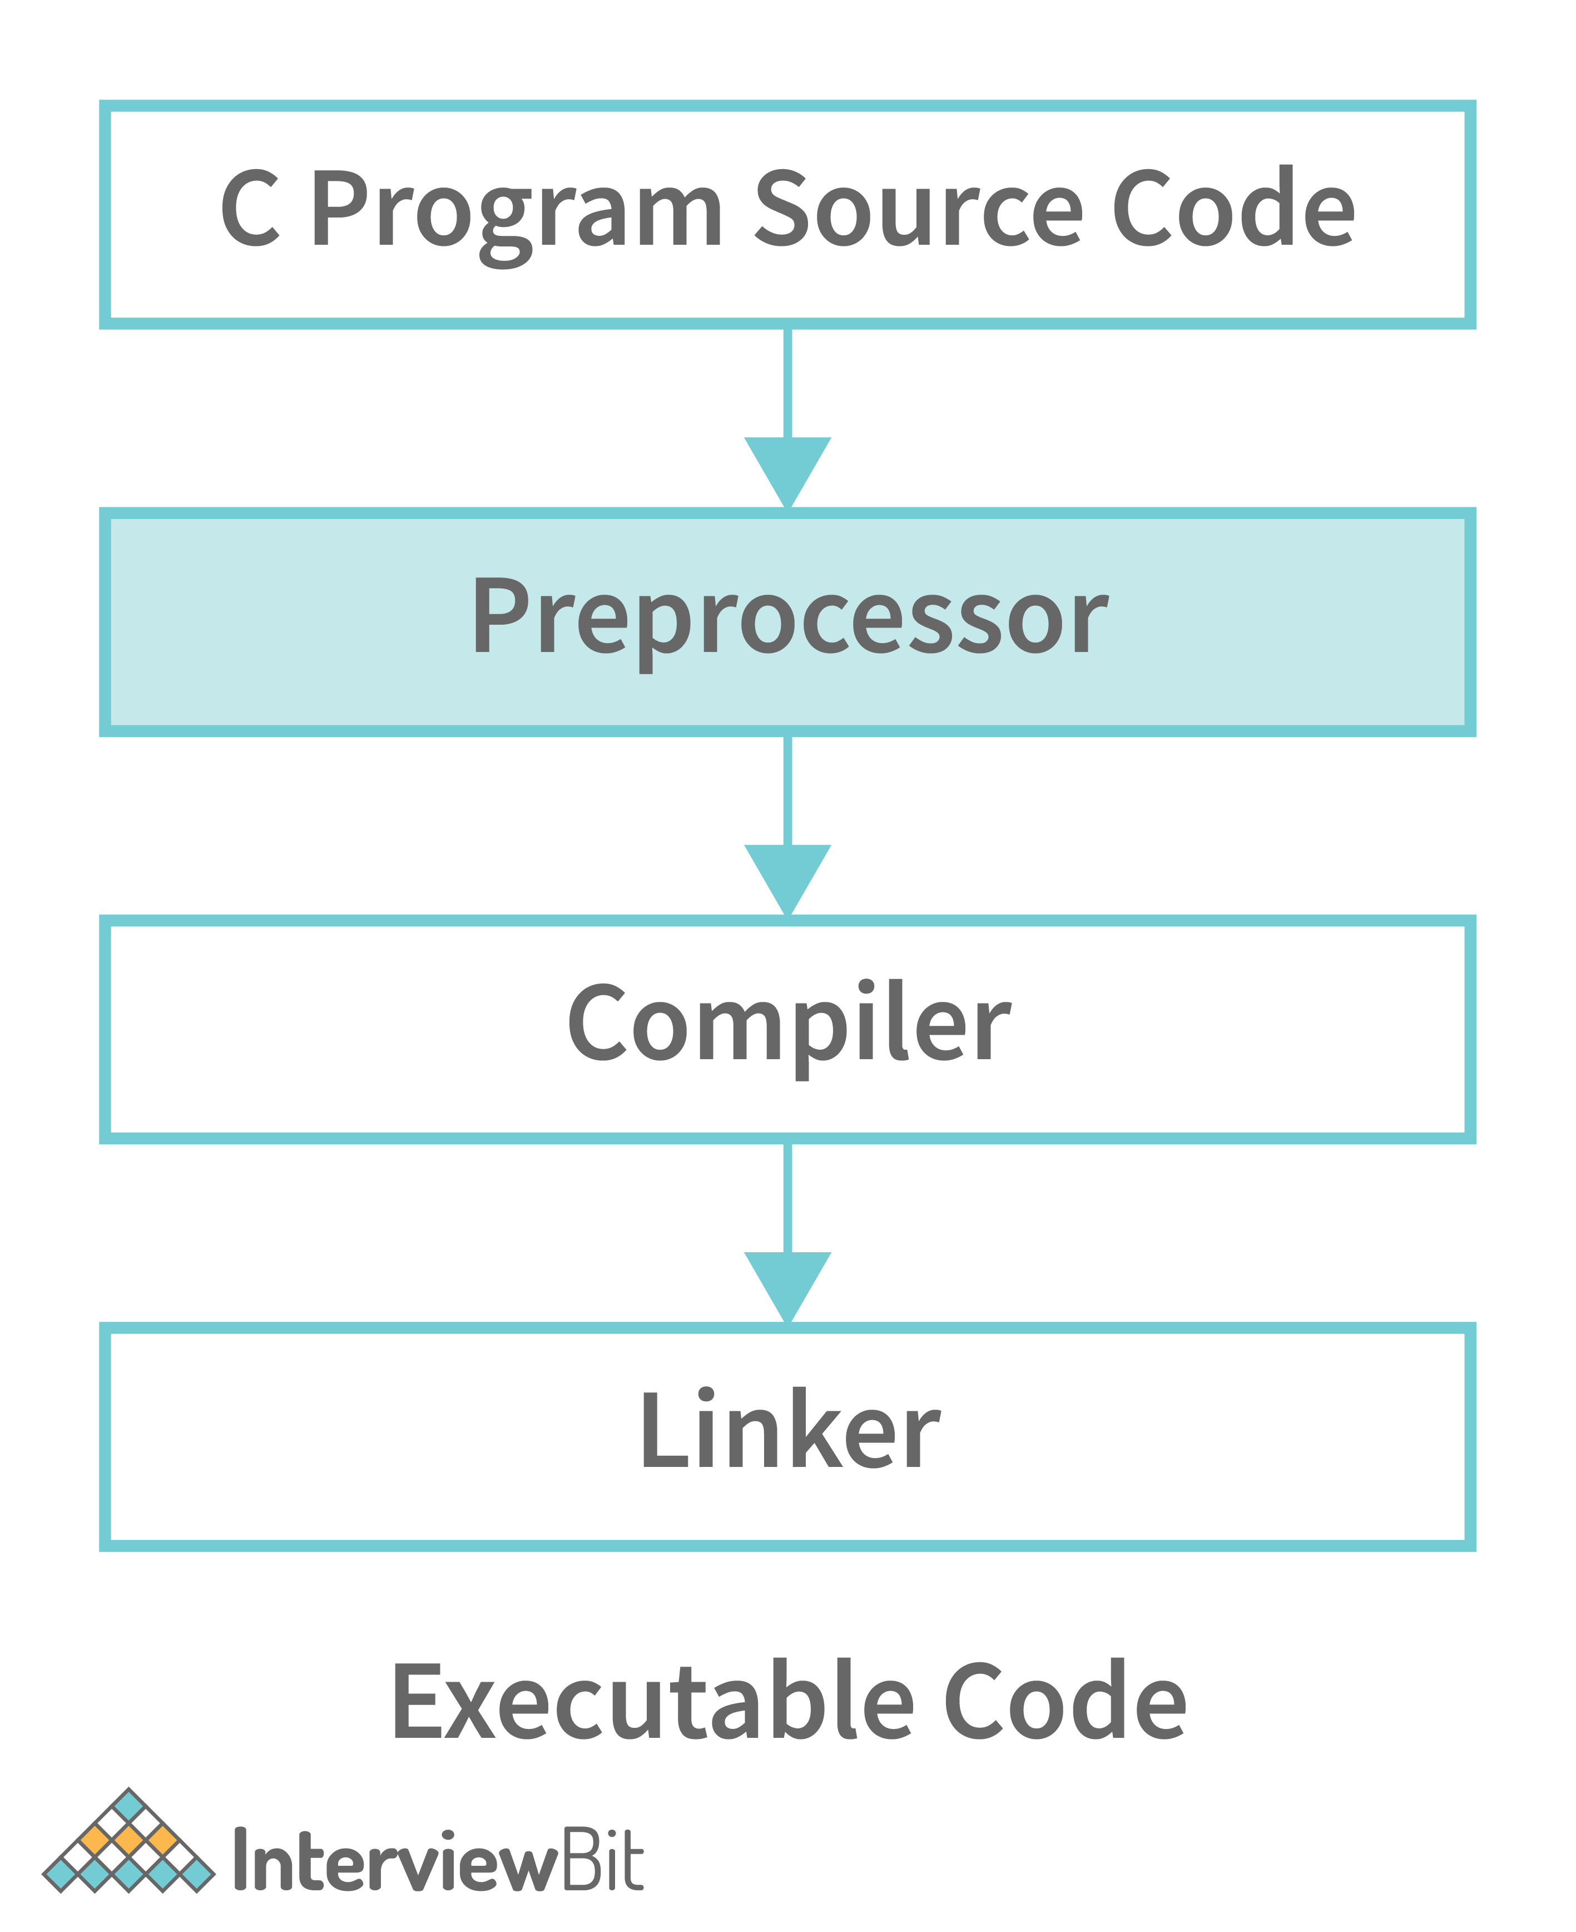

Advance your career with Mock Assessments
Real-world coding challenges for top company interviews
Real-Life Problems
Detailed reports
Attempt Now

8. In C, What is the #line used for?
In C, #line is used as a preprocessor to re-set the line number in the code, which takes a parameter as line number. Here is an example for the same.
#include <stdio.h> /*line 1*/
/*line 2*/
int main(){ /*line 3*/
/*line 4*/
printf("Hello world\n"); /*line 5*/
//print current line /*line 6*/
printf("Line: %d\n",__LINE__); /*line 7*/
//reset the line number by 36 /*line 8*/
#line 36 /*reseting*/
//print current line /*line 36*/
printf("Line: %d\n",__LINE__); /*line 37*/
printf("Bye bye!!!\n"); /*line 39*/
/*line 40*/
return 0; /*line 41*/
} /*line 42*/

9. How can a string be converted to a number?
The function takes the string as an input that needs to be converted to an integer.
int atoi(const char *string)
Return Value:
- On successful conversion, it returns the desired integer value
- If the string starts with alpha-numeric char or only contains alpha-num char, 0 is returned.
- In case string starts with numeric character but is followed by alpha-num char, the string is converted to integer till the first occurrence of alphanumeric char.
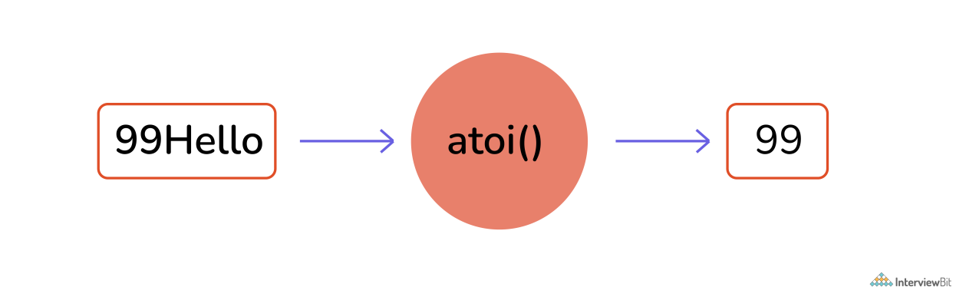Converting String to Number

10. How can a number be converted to a string?
The function takes a pointer to an array of char elements that need to be converted, and a format string needs to be written in a buffer as a string
int sprintf(char *str, const char *format, ...)

The output after running the above code:
Output: Value of Pi = 3.141593

11. What is recursion in C?
When a function in C calls a copy of itself, this is known as recursion. To put it another way, when a function calls itself, this technique is called Recursion. Also, this function is known as recursive function.
Syntax of Recursive Function:
void do_recursion()
{
... .. ...
do_recursion();
... .. ...]
}
int main()
{
... .. ...
do_recursion();
... .. ...
}

12. Why doesn’t C support function overloading?
After you compile the C source, the symbol names need to be intact in the object code. If we introduce function overloading in our source, we should also provide name mangling as a preventive measure to avoid function name clashes. Also, as C is not a strictly typed language many things(ex: data types) are convertible to each other in C. Therefore, the complexity of overload resolution can introduce confusion in a language such as C.
When you compile a C source, symbol names will remain intact. If you introduce function overloading, you should provide a name mangling technique to prevent name clashes. Consequently, like C++, you'll have machine-generated symbol names in the compiled binary.
Additionally, C does not feature strict typing. Many things are implicitly convertible to each other in C. The complexity of overload resolution rules could introduce confusion in such kind of language

Get Access to 250+ Guides with Scaler Mobile App!
Experience free learning content on the Scaler Mobile App

4.5
100K+
Play Store

13. What is the difference between global int and static int declaration?
The difference between this is in scope. A truly global variable has a global scope and is visible everywhere in your program.
#include <stdio.h>
int my_global_var = 0;
int main(void)
{
printf("%d\n", my_global_var);
return 0;
}
global_temp is a global variable that is visible to everything in your program, although to make it visible in other modules, you'd need an ”extern int global_temp; ” in other source files if you have a multi-file project.
A static variable has a local scope but its variables are not allocated in the stack segment of the memory. It can have less than global scope, although - like global variables - it resides in the .bss segment of your compiled binary.
#include <stdio.h>
int myfunc(int val)
{
static int my_static_var = 0;

my_static_var += val;
return my_static_var;
}
int main(void)
{
int myval;

myval = myfunc(1);
printf("first call %d\n", myval);

myval = myfunc(10);

printf("second call %d\n", myval);

return 0;
}

14. What is a pointer in C?
A pointer is a variable that stores or points to another variable's address. The value of a variable is stored in a normal variable, whereas the address of a variable is stored in a pointer variable.
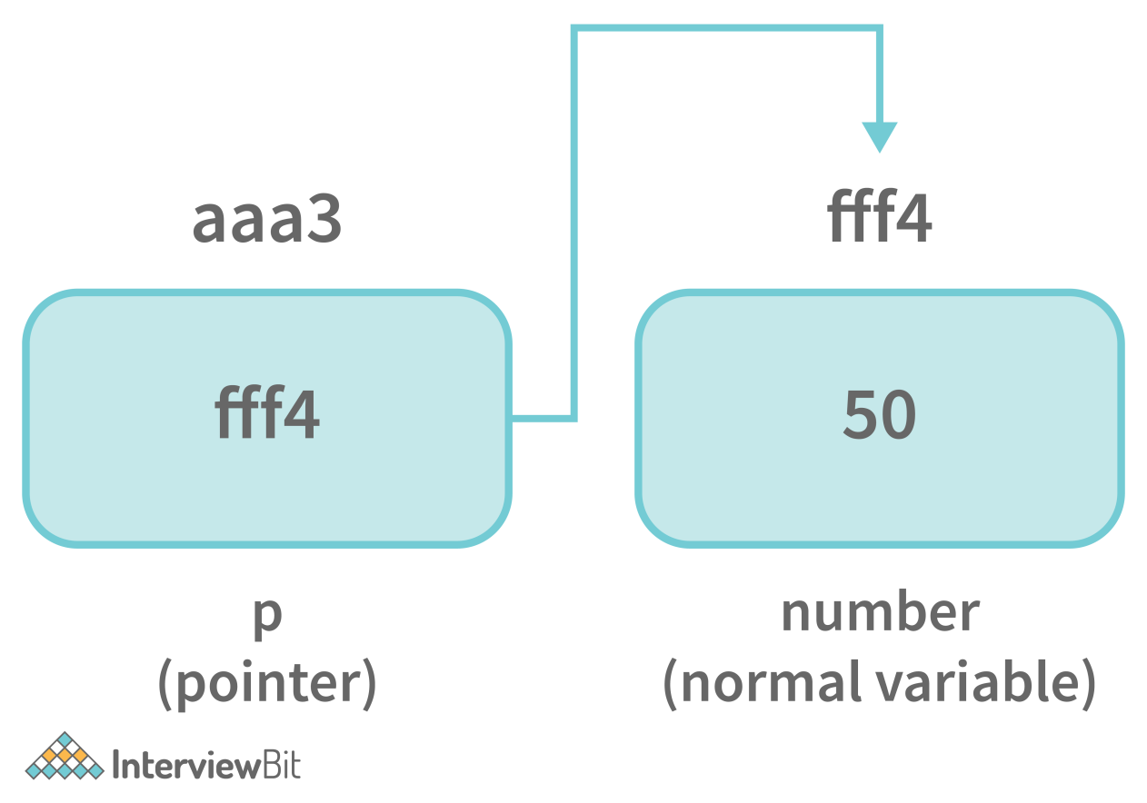

15. Difference between const char* p and char const* p?
- const char* p is a pointer to a const char.
- char const* p is a pointer to a char const.
Since const char and char const are the same, it's the same.

16. What is pointer to pointer in C?
In C, a pointer can also be used to store the address of another pointer. A double pointer or pointer to pointer is such a pointer. The address of a variable is stored in the first pointer, whereas the address of the first pointer is stored in the second pointer.
The syntax of declaring a double pointer is given below:
int **p; // pointer to a pointer which is pointing to an integer

17. Why n++ executes faster than n+1 ?
n++ being a unary operation, it just needs one variable. Whereas, n = n + 1 is a binary operation that adds overhead to take more time (also binary operation: n += 1). However, in modern platforms, it depends on few things such as processor architecture, C compiler, usage in your code, and other factors such as hardware problems.
While in the modern compiler even if you write n = n + 1 it will get converted into n++ when it goes into the optimized binary, and it will be equivalently efficient.
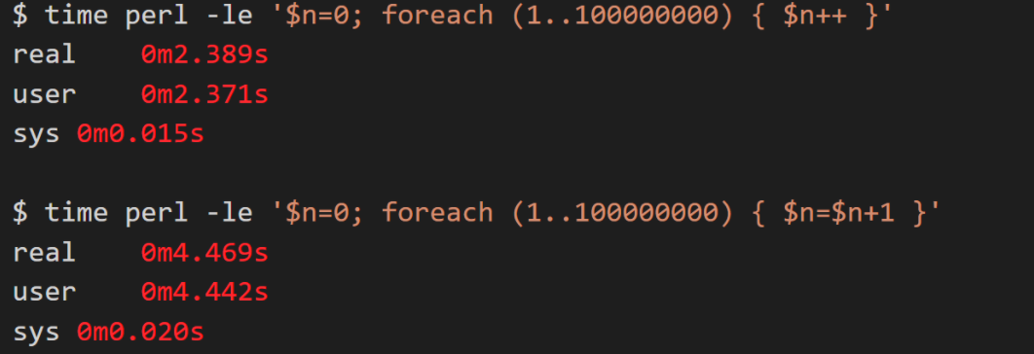

18. What is typecasting in C?
Typecasting is the process to convert a variable from one datatype to another. If we want to store the large type value to an int type, then we will convert the data type into another data type explicitly.
Syntax: (data_type)expression;
For Example:
int x;
for(x=97; x<=122; x++)
{
printf("%c", (char)x); /*Explicit casting from int to char*/
}

19. What are the advantages of Macro over function?
Macro on a high-level copy-paste, its definitions to places wherever it is called. Due to which it saves a lot of time, as no time is spent while passing the control to a new function and the control is always with the callee function. However, one downside is the size of the compiled binary is large but once compiled the program comparatively runs faster.

20. What are Enumerations?
Enumeration, also known as Enum in C, is a user-defined data type. It consists of constant integrals or integers that have names assigned to them by the user. Because the integer values are named with enum in C, the whole program is simple to learn, understand, and maintain by the same or even different programmer.

21. When should we use the register storage specifier?
If a variable is used frequently, it should be declared with the register storage specifier, and the compiler may allocate a CPU register for its storage to speed up variable lookup.

1. What is Embedded C and how does it differ from standard C?
Why you might get asked this: Understanding the differences between Embedded C and standard C is crucial for roles that involve programming microcontrollers, as it highlights your ability to optimize code for hardware-specific constraints and real-time performance requirements.
How to answer:
Define Embedded C as a set of language extensions for the C programming language to support embedded processors.
Highlight that Embedded C includes features like fixed-point arithmetic, I/O register mapping, and addressing hardware interrupts.
Explain that the main difference is the focus on direct hardware manipulation and real-time constraints, unlike standard C which is more general-purpose.
Example answer:
"Embedded C is a set of language extensions for the C programming language designed to support embedded processors. Unlike standard C, it includes features like fixed-point arithmetic, I/O register mapping, and addressing hardware interrupts, focusing on direct hardware manipulation and real-time constraints."
2. Explain the concept of pointers in Embedded C. Provide an example of how to use pointers to manipulate an array.
Why you might get asked this: Understanding pointers and their manipulation of arrays is fundamental in Embedded C programming, as it demonstrates your ability to efficiently manage memory and optimize performance, which is crucial for roles such as embedded software engineer.
How to answer:
Define pointers as variables that store memory addresses.
Explain how pointers can be used to access and manipulate array elements directly.
Provide a simple code example demonstrating pointer arithmetic to iterate through an array.
Example answer:
"Pointers in Embedded C are variables that store the memory address of another variable, allowing for efficient memory management and manipulation. For example, using a pointer to iterate through an array can be done with the following code:
int arr[] = {1, 2, 3};
int *ptr = arr;
for(int i = 0; i < 3; i++)
{ *(ptr + i) = *(ptr + i) * 2; }"
3. Write a simple program to toggle an LED connected to a microcontroller pin.
Why you might get asked this: Demonstrating the ability to write a simple program to toggle an LED connected to a microcontroller pin showcases your practical skills in embedded systems programming, which is essential for roles such as embedded software engineer.
How to answer:
Explain the basic setup of the microcontroller and the LED connection.
Describe the initialization of the microcontroller pin as an output.
Provide a simple code example that includes a loop to toggle the LED state.
Example answer:
"To toggle an LED connected to a microcontroller pin, you need to set the pin as an output and then use a loop to change its state. Here is a simple code example:
DDRB |= (1 << PB0);
while(1) {
PORTB ^= (1 << PB0);
_delay_ms(500);
}"
4. What are the different data types available in Embedded C? Give examples of when to use each.
Why you might get asked this: Understanding the different data types available in Embedded C and their appropriate use cases is fundamental for optimizing memory usage and performance, which is crucial for roles such as embedded software engineer.
How to answer:
List the primary data types such as int, char, float, and double.
Explain the use of int for general-purpose variables and loop counters.
Describe using char for storing characters and small integers, and float or double for precision-required calculations.
Example answer:
"Embedded C offers various data types such as int, char, float, and double. For instance, use intfor loop counters, char for characters, and float or double for precise calculations."
5. Describe the role of header files in Embedded C programming. How do you create and include a custom header file?
Why you might get asked this: Understanding the role of header files in Embedded C programming is essential for organizing code and managing dependencies, which is crucial for maintaining large projects, such as those encountered by embedded software engineers.
How to answer:
Explain that header files are used to declare functions, macros, and data types to be shared across multiple source files.
Describe the process of creating a custom header file by writing declarations in a .h file.
Mention including the custom header file in the source file using the #include directive.
Example answer:
"Header files in Embedded C are used to declare functions, macros, and data types that can be shared across multiple source files, ensuring code modularity and reusability. To create a custom header file, write your declarations in a .h file and include it in your source file using #include "your_header.h"."
6. Write a function to read a value from an analog-to-digital converter (ADC) and return the result.
Why you might get asked this: Demonstrating the ability to write a function to read a value from an analog-to-digital converter (ADC) and return the result is crucial for roles that involve interfacing with sensors and other analog devices, such as an embedded systems engineer.
How to answer:
Explain the initialization of the ADC module.
Describe the process of starting the ADC conversion and waiting for it to complete.
Provide a simple code example that reads the ADC value and returns it.
Example answer:
"To read a value from an ADC, initialize the ADC module, start the conversion, and wait for it to complete. Here is a simple function:
uint16_t readADC()
{ ADCSRA |= (1 << ADSC);
while (ADCSRA & (1 << ADSC));
return ADC; }"
7. Explain the use of volatile keyword in Embedded C. Provide a coding example where it is necessary.
Why you might get asked this: Understanding the use of the volatile keyword in Embedded C is crucial for ensuring proper handling of variables that can change unexpectedly, such as those used in interrupt service routines, which is essential for roles like embedded software engineer.
How to answer:
Define the volatile keyword as a type qualifier that prevents the compiler from optimizing variables that can change unexpectedly.
Explain that it is used for variables modified by interrupts or hardware.
Provide a code example where a volatile variable is used in an interrupt service routine to ensure the correct value is read.
Example answer:
"The volatile keyword in Embedded C is used to indicate that a variable's value may change unexpectedly, preventing the compiler from optimizing it. For instance, a variable shared between the main program and an interrupt service routine should be declared as volatile to ensure the main program always reads the latest value."
8. How do you implement a simple state machine in Embedded C? Write a code snippet to demonstrate this.
Why you might get asked this: Understanding how to implement a simple state machine in Embedded C is crucial for managing complex control flows in embedded systems, which is essential for roles such as embedded software engineer.
How to answer:
Define a state machine as a model of computation consisting of states, transitions, and actions.
Explain the use of an enumeration to define the states and a switch-case structure to handle state transitions.
Provide a simple code snippet that demonstrates a basic state machine implementation.
Example answer:
"To implement a simple state machine in Embedded C, define the states using an enumeration and handle state transitions with a switch-case structure. Here is a basic example:
enum State {IDLE, RUNNING, STOPPED};
enum State currentState = IDLE;
switch(currentState) {
case IDLE: // actions;
currentState = RUNNING;
break; case RUNNING: // actions;
currentState = STOPPED;
break;
case STOPPED: // actions;
currentState = IDLE;
break; }""
9. What is the purpose of the main() function in an Embedded C program? Can you provide an example of a typical main function structure?
Why you might get asked this: Understanding the purpose and structure of the main() function in an Embedded C program is fundamental for roles that involve developing and maintaining embedded systems, such as an embedded software engineer, as it demonstrates your ability to initialize and control the program's execution flow.
How to answer:
Define the main() function as the entry point of an Embedded C program where execution begins.
Explain that it typically includes initialization of hardware and peripherals, and the main control loop.
Provide a simple code example that demonstrates a typical structure of the main() function.
Example answer:
"The main() function in an Embedded C program serves as the entry point where execution begins. It typically includes hardware initialization and the main control loop, ensuring the program runs as intended."
10. Write a program to implement a basic UART communication to send a string of characters.
Why you might get asked this: Demonstrating the ability to write a program for basic UART communication to send a string of characters is essential for roles that involve serial communication with peripherals, such as an embedded software engineer.
How to answer:
Explain the initialization of the UART module with the correct baud rate.
Describe the process of configuring the UART settings such as data bits, stop bits, and parity.
Provide a simple code example that sends a string of characters using the UART module.
Example answer:
"To implement basic UART communication to send a string of characters, initialize the UART module with the correct baud rate and configure the UART settings such as data bits, stop bits, and parity. Here is a simple code example:
void UART_sendString(char *str)
{ while(*str) { while (!(UCSRA & (1 << UDRE))); UDR = *str++; } }"
11. Explain the difference between blocking and non-blocking code. Provide an example of each in Embedded C.
Why you might get asked this: Understanding the difference between blocking and non-blocking code is crucial for optimizing system performance and responsiveness, which is essential for roles such as embedded software engineer.
How to answer:
Define blocking code as code that waits for an operation to complete before proceeding.
Explain non-blocking code as code that allows other operations to continue while waiting for an operation to complete.
Provide a simple code example for each, such as a blocking delay function and a non-blocking UART receive function.
Example answer:
"Blocking code waits for an operation to complete before moving on, while non-blocking code allows other operations to continue during the wait. For example, a blocking delay function might use _delay_ms(1000);, whereas a non-blocking UART receive function could use
if (UCSRA & (1 << RXC))
{ char data = UDR; }."
12. How do you handle interrupts in Embedded C? Write a code example that demonstrates setting up an interrupt service routine (ISR).
Why you might get asked this: Understanding how to handle interrupts in Embedded C is crucial for ensuring timely and efficient responses to hardware events, which is essential for roles such as embedded software engineer.
How to answer:
Explain the concept of interrupts and their importance in embedded systems.
Describe the steps to configure and enable an interrupt in the microcontroller.
Provide a simple code example that sets up an interrupt service routine (ISR) to handle an external interrupt.
Example answer:
"Handling interrupts in Embedded C involves configuring the interrupt registers and writing an interrupt service routine (ISR) to manage the interrupt event. For example, to set up an external interrupt on INT0, you can use the following code:
GICR |= (1 << INT0); MCUCR |= (1 << ISC01); ISR(INT0_vect)
{ // ISR code }"
13. Write a function to implement a delay using a loop. Explain how the delay can be adjusted.
Why you might get asked this: Demonstrating the ability to write a function to implement a delay using a loop and explain how the delay can be adjusted is crucial for roles that require precise timing control, such as an embedded software engineer.
How to answer:
Explain the basic concept of using a loop to create a delay.
Describe how the loop counter value determines the length of the delay.
Provide a simple code example and explain how to adjust the delay by changing the loop counter value.
Example answer:
"To implement a delay using a loop, you can create a simple function that uses a nested loop to create the delay. The length of the delay can be adjusted by changing the loop counter values. For example,
void delay(int milliseconds) {
for(int i = 0; i < milliseconds; i++)
{ for(int j = 0; j < 1000; j++); } }."
14. What are the common pitfalls when using pointers in Embedded C? Provide examples.
Why you might get asked this: Understanding the common pitfalls when using pointers in Embedded C is crucial for avoiding bugs and ensuring robust code, which is essential for roles such as embedded software engineer.
How to answer:
Explain that common pitfalls include dereferencing null or uninitialized pointers.
Describe the issue of pointer arithmetic leading to out-of-bounds access.
Provide an example of a memory leak caused by not freeing dynamically allocated memory.
Example answer:
"Common pitfalls when using pointers in Embedded C include dereferencing null or uninitialized pointers, which can lead to undefined behavior. Another issue is pointer arithmetic that results in out-of-bounds access, potentially causing memory corruption."
15. Describe how to use bit manipulation to set, clear, and toggle bits in a register. Write a code example.
Why you might get asked this: Understanding how to use bit manipulation to set, clear, and toggle bits in a register is crucial for efficiently managing hardware control registers, which is essential for roles such as embedded software engineer.
How to answer:
Explain that bit manipulation involves using bitwise operators to directly control individual bits in a register.
Describe the use of bitwise OR to set bits, AND with NOT to clear bits, and XOR to toggle bits.
Provide a code example demonstrating these operations:
register |= (1 << bit);
register &= ~(1 << bit);
register ^= (1 << bit);
Example answer:
"To use bit manipulation to set, clear, and toggle bits in a register, you can use bitwise operators. For example, to set a bit, use register |= (1 << bit);, to clear a bit, use register &= ~(1 << bit);, and to toggle a bit, use register ^= (1 << bit);."
16. Write a program to read a digital input from a switch and turn on an LED based on the switch state.
Why you might get asked this: Demonstrating the ability to write a program to read a digital input from a switch and turn on an LED based on the switch state showcases your practical skills in interfacing with hardware components, which is essential for roles such as embedded software engineer.
How to answer:
Explain the initialization of the microcontroller pins for the switch input and LED output.
Describe the process of reading the switch state and using conditional statements to control the LED.
Provide a simple code example that demonstrates reading the switch state and turning the LED on or off accordingly.
Example answer:
"To read a digital input from a switch and turn on an LED based on the switch state, initialize the microcontroller pins for the switch input and LED output. Here is a simple code example: DDRB |= (1 << PB0); DDRD &= ~(1 << PD0); while(1) { if (PIND & (1 << PD0)) { PORTB |= (1 << PB0); } else { PORTB &= ~(1 << PB0); } }"
17. Explain the concept of memory mapping in Embedded systems. How does it affect your code?
Why you might get asked this: Understanding the concept of memory mapping in embedded systems is crucial for optimizing code and managing hardware resources efficiently, which is essential for roles such as embedded software engineer.
How to answer:
Define memory mapping as the process of assigning specific memory addresses to hardware components and peripherals.
Explain that it allows direct access to hardware registers and memory locations, facilitating efficient control and data transfer.
Mention that improper memory mapping can lead to conflicts and unpredictable behavior, affecting the stability and performance of your code.
Example answer:
"Memory mapping in embedded systems involves assigning specific memory addresses to hardware components and peripherals, allowing direct access to hardware registers and memory locations. This approach facilitates efficient control and data transfer, but improper memory mapping can lead to conflicts and unpredictable behavior, affecting the stability and performance of your code."
18. Write a function to convert a binary number to decimal in Embedded C.
Why you might get asked this: Understanding how to convert a binary number to decimal in Embedded C demonstrates your ability to handle fundamental data manipulation tasks, which is crucial for roles that require low-level programming, such as an embedded software engineer.
How to answer:
Explain the concept of binary to decimal conversion by iterating through each bit of the binary number.
Describe the use of bitwise operations to extract each bit and calculate its decimal value.
Provide a simple code example that demonstrates the conversion process in Embedded C.
Example answer:
"To convert a binary number to decimal in Embedded C, iterate through each bit of the binary number, using bitwise operations to extract each bit and calculate its decimal value. Here is a simple function: int binaryToDecimal(int binary) { int decimal = 0, base = 1; while (binary > 0) { int last_digit = binary % 10; binary = binary / 10; decimal += last_digit * base; base = base * 2; } return decimal; }"
19. What is the purpose of the preprocessor directives in Embedded C? Provide examples of commonly used directives.
Why you might get asked this: Understanding the purpose of preprocessor directives in Embedded C is crucial for roles that involve code optimization and modularity, such as an embedded software engineer, as it demonstrates your ability to manage code compilation and configuration efficiently.
How to answer:
Explain that preprocessor directives are used to manage code compilation and configuration.
Describe how they can include header files, define constants, and conditionally compile code.
Provide examples such as #include, #define, and #ifdef.
Example answer:
"Preprocessor directives in Embedded C manage code compilation and configuration, allowing for modular and efficient code. Common examples include #include for including header files, #definefor defining constants, and #ifdef for conditional compilation."
20. Write a program to implement a simple PWM signal generation for controlling the brightness of an LED.
Why you might get asked this: Demonstrating the ability to write a program to implement a simple PWM signal generation for controlling the brightness of an LED showcases your practical skills in managing hardware control signals, which is essential for roles such as an embedded software engineer.
How to answer:
Explain the basic concept of Pulse Width Modulation (PWM) and its use in controlling LED brightness.
Describe the initialization of the PWM module and setting the duty cycle.
Provide a simple code example that demonstrates generating a PWM signal to control LED brightness.
Example answer:
"To implement a simple PWM signal generation for controlling the brightness of an LED, initialize the PWM module and set the duty cycle. Here is a simple code example: OCR0A = 128; TCCR0A |= (1 << COM0A1) | (1 << WGM00) | (1 << WGM01); TCCR0B |= (1 << CS01);"
21. Explain the difference between static and dynamic memory allocation. Provide examples in Embedded C.
Why you might get asked this: Understanding the difference between static and dynamic memory allocation is crucial for optimizing memory usage and performance in embedded systems, which is essential for roles such as embedded software engineer.
How to answer:
Define static memory allocation as memory allocated at compile time.
Explain dynamic memory allocation as memory allocated at runtime using functions like malloc()and free().
Provide examples such as declaring a static array for static allocation and using malloc() to allocate memory for a dynamic array.
Example answer:
"Static memory allocation is done at compile time, while dynamic memory allocation is done at runtime using functions like malloc() and free(). For example, a static array can be declared as int arr[10];, whereas a dynamic array can be allocated using int *arr = (int *)malloc(10 * sizeof(int));."
22. Write a function to implement a circular buffer for storing data in Embedded C.
Why you might get asked this: Understanding how to implement a circular buffer for storing data in Embedded C is crucial for efficiently managing data streams and memory, which is essential for roles that involve real-time data processing, such as an embedded software engineer.
How to answer:
Explain the concept of a circular buffer and its advantages for continuous data storage.
Describe the initialization of the buffer, including setting up the buffer array and pointers.
Provide a simple code example that demonstrates adding and removing data from the circular buffer.
Example answer:
"An amazing answer would include a clear explanation of the circular buffer concept and a concise, well-commented code snippet. For example,
void addToBuffer(int data)
{
buffer[head] = data;
head = (head + 1)
% BUFFER_SIZE;
}"
23. How do you perform error handling in Embedded C? Write a code snippet that demonstrates error checking.
Why you might get asked this: Understanding how to perform error handling in Embedded C is crucial for ensuring robust and reliable code, which is essential for roles that require maintaining system stability, such as an embedded software engineer.
How to answer:
Explain the importance of error handling in ensuring system stability and reliability.
Describe common techniques such as return codes, error flags, and assertions.
Provide a simple code snippet that demonstrates checking for an error condition and handling it appropriately.
Example answer:
"An amazing answer would include a clear explanation of the importance of error handling and a concise, well-commented code snippet. For example, if (readSensor() == ERROR) { handleError(); }"
24. Describe the process of debugging an Embedded C program. What tools and techniques do you use?
Why you might get asked this: Understanding the process of debugging an Embedded C program is crucial for identifying and resolving issues efficiently, which is essential for roles that require maintaining system stability, such as an embedded software engineer.
How to answer:
Explain the importance of systematic debugging to identify and resolve issues efficiently.
Mention using tools like JTAG debuggers, oscilloscopes, and logic analyzers for hardware-level debugging.
Describe techniques such as setting breakpoints, stepping through code, and using print statements for software-level debugging.
Example answer:
"An amazing answer would include a clear explanation of the importance of systematic debugging and a concise description of the tools and techniques used. For example, using a JTAG debugger to set breakpoints and stepping through the code to identify issues."
25. Write a program to interface with a temperature sensor and display the temperature value on a serial monitor.
Why you might get asked this: Demonstrating the ability to write a program to interface with a temperature sensor and display the temperature value on a serial monitor showcases your practical skills in sensor interfacing and data communication, which is essential for roles that involve real-time monitoring and control, such as an embedded software engineer.
How to answer:
Explain the initialization of the temperature sensor and the serial communication module.
Describe the process of reading the temperature value from the sensor.
Provide a simple code example that reads the temperature and sends it to the serial monitor.
Example answer:
"An amazing answer would include a clear explanation of the initialization process and a concise, well-commented code snippet. For example,
void readTemperature()
{
int temp = readSensor();
Serial.print("Temperature: ");
Serial.println(temp);
}"

Q1. What is C programming?
Ans. C is one of the oldest programming languages and was developed in 1972 by Dennis Ritchie. It is a high-level, general-purpose, and structured programming language that is widely used in various tasks, such as developing system applications, desktop applications, operating systems as well as IoT applications. It is the simple and flexible language used for a variety of scripting system applications, which form a significant part of Windows, UNIX, and Linux operating systems.

Q2. Why is C dubbed as a mother language?
Ans. It is known as a mother language because most of the JVMs, compilers, and Kernels are written in C language. If you know C, then you can easily grasp other programming languages.

Q3. Who is the founder of the C language? When was the C language developed?
Ans. C is developed by Dennis M. Ritchie in 1972 at the Bell laboratories of AT & T.

Q4. What are the key features of the C Programming language?
Ans. The following are the major features of C:
- Machine Independent
- Mid-Level programming language
- Memory Management
- Structured programming language
- Simple and efficient
- Function rich libraries
- Case Sensitive

Q5. Name some different storage class specifiers in C?
Ans. Storage classes represent the storage of any variable. There are four storage classes in C:
- Auto
- Register
- Extern
- Static

Q6. What are the data types supported in the C Programming language?
Ans. This is one of the commonly asked C programming interview questions. The data type specifies the type of data used in programming. C language has some predefined data types with different storage capacities:
- Built-in data types: It includes int, char, double, float and void
- Derived data types: It includes array, pointers, and references
- User-defined data types: Union, structure, and Enumeration

Q7. What do you mean by the scope and lifetime of a variable in C?
Ans. The scope and lifetime of any variable are defined as the section of the code in which the variable is executable or visible. Variables that are described in the block are only accessible in the block. The variable’s lifetime defines the variable’s existence before it is destroyed.

Q8. What do you mean by the pointer in C?
Ans. Pointers are the variables in C that store the address of another variable. It allocates the memory for the variable at the run time. The pointer might be of different data types such as int, char, float, double, etc.
Example:
#include < stdio.h >
int main()
{
int *ptr, q;
q = 50;

/* address of q is assigned to ptr */
ptr = &q;

/* display q’s value using ptr variable */
printf(“%d”, *ptr);
return 0;
}

Q9. Define Null pointer?
Ans. A null pointer represents the empty location in the computer’s memory. It is used in C for various purposes:
- It will assign the pointer variable to the variable with no assigned memory
- In pointer related code we can do error handling by checking null pointer before assigning any pointer variable
- Pass a null pointer to the variable if we don’t want to pass any valid memory address
Example:
int fun(int *ptr)
{
/*Fun specific stuff is done with ptr here*/
return 10;
}

fun(NULL);

Copy code

Q10. What is Dangling Pointer?
Ans. Dangling pointers are the pointers pointing to the memory location that has been deleted or released. There are three different types of dangling pointers:

Return local variable in a function call
#include < stdio.h >
#include < string.h >

char *getHello()
{
char str[10];
strcpy(str,”Hello!”);
return(str);
}

int main()
{
//str falls out of scope
//function call char *getHello() is now a dangling pointer
printf(“%s”, getHello());
}

Variable goes out of scope
void main()
{
int *p1;
…..
{
int ch;
p1 = &ch;
}
…..
// Here ptr is a dangling pointer
}

De allocation or free variable memory
#include < stdio.h >
#include < stdlib.h >

int main()
{
char **strPtr;
char *str = “Hello!”;
strPtr = &str;
free(str);
//strPtr is now a dangling pointer
printf(“%s”, *strPtr);
}

Q11. What is the use of function in C?
Ans. Functions are the basic building blocks of any programming language. All C programs are written using the function to maintain reusability and understandability.
Uses of functions in C:
- Functions can be used multiple times in a program by calling them whenever required
- In C, functions are used to avoid rewriting of code
- It is easy to track any C program when it is divided into functions
Syntax of a function
return_type function_name( parameter list )
{
//body of the function
}

Q12. What happens when you compile a program in C?
Ans. At the time of compilation, the compiler generates a file with the same name as the C program file with different extensions.
Below is the image to show the compilation process:
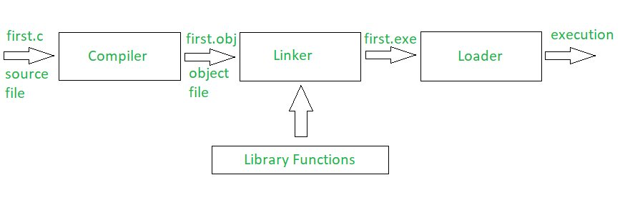

Q13. What are header files in C?
Ans. Header files are those which contain C function declaration and macro definitions that are to be shared between sourced files. Header files are generated with the extension .h.
There are two types of header files:
- Programmer generated a header file
- Files that come with your compiler
Syntax: #include <file>

Q14. How many types of operators are there in C Programming?
Ans. An operator is a symbol used to operate the values of variables. There is a wide range of operators used in C programming, including –

Arithmetic Operators:
These are used to perform mathematical calculations such as addition, subtraction, multiplication, division, and modulus.
Example:
#include < stdio.h >

int main()
{
int a = 9,b = 4, c;
c = a+b;
printf(“a+b = %d \n”,c);
c = a-b;
printf(“a-b = %d \n”,c);
c = a*b;
printf(“a*b = %d \n”,c);
c = a/b;
printf(“a/b = %d \n”,c);
c = a%b;
printf(“Remainder when a divided by b = %d \n”,c);
return 0;
}
Copy code

Relational Operators:
These are used to check the relation between two operands. If the relation is TRUE, it returns 1; If the relation is FALSE, It returns 0.
Example:
#include < stdio.h >

int main()
{
int a = 2, b = 2, c = 6;
printf(“%d == %d is %d \n”, a, b, a == b);
printf(“%d == %d is %d \n”, a, c, a == c);
printf(“%d > %d is %d \n”, a, b, a > b);
printf(“%d > %d is %d \n”, a, c, a > c);
printf(“%d < %d is %d \n”, a, b, a < b);
printf(“%d < %d is %d \n”, a, c, a < c);
printf(“%d != %d is %d \n”, a, b, a != b);
printf(“%d != %d is %d \n”, a, c, a != c);
printf(“%d > = %d is %d \n”, a, b, a > = b);
printf(“%d > = %d is %d \n”, a, c, a > = c);
printf(“%d < = %d is %d \n”, a, b, a < = b);
printf(“%d < = %d is %d \n”, a, c, a < = c);
return 0;
}
Copy code

Logical Operators:
These are used in decision-making operations. If the expression is TRUE, it returns 1; if the expression is FALSE, it returns 0.
Example:
#include < stdio.h >

int main()
{
int a = 2, b = 2, c = 6, result;
result = (a == b) && (c > b);
printf(“(a == b) && (c > b) is %d \n”, result);
result = (a == b) && (c < b);
printf(“(a == b) && (c < b) is %d \n”, result);
result = (a == b) || (c < b);
printf(“(a == b) || (c < b) is %d \n”, result);
result = (a != b) || (c < b);
printf(“(a != b) || (c < b) is %d \n”, result);
result = !(a != b);
printf(“!(a == b) is %d \n”, result);
result = !(a == b);
printf(“!(a == b) is %d \n”, result);
return 0;
}
Copy code

Assignment Operators:
These are used to assign value to a variable. The most used assignment operator is ‘=’.
Example:
#include < stdio.h >
int main()
{
int a = 5, c;
c = a; // c is 5
printf(“c = %d\n”, c);
c += a; // c is 10
printf(“c = %d\n”, c);
c -= a; // c is 5
printf(“c = %d\n”, c);
c *= a; // c is 25
printf(“c = %d\n”, c);
c /= a; // c is 5
printf(“c = %d\n”, c);
c %= a; // c = 0
printf(“c = %d\n”, c);
return 0;
}
Copy code

Increment and Decrement Operators:
These are used to change the value of an operand (constant or variable) by 1.
Example:
#include < stdio.h >
int main()
{
int a = 10, b = 100;
float c = 10.5, d = 100.5;
printf(“++a = %d \n”, ++a);
printf(“–b = %d \n”, –b);
printf(“++c = %f \n”, ++c);
printf(“–d = %f \n”, –d);
return 0;
}
Copy code

Bitwise Operators:
These are used to perform bit-level operations between two variables.
Example: Bitwise OR, Bitwise AND

Conditional Operator:
These are used in conditional expressions.
Example: ‘?:’ Conditional operator

Special Operators:
There are some special operators in C used for:
sizeof(): Returns the size of the memory location
&: Returns the address of a memory location
*: Pointer of a variable

Q15. Explain the process of creating increment and decrement operators in C.
Ans. This is one of the most important C programming interview questions. If you want to perform an increment operation, then use ‘i++,’ which will increase the value by 1. If you want to perform a decrement operation, then use ‘i–,’ it will decrease the value by 1.
Example:
#include < stdio.h >

int main()
{
int x = 10, y = 1;
printf(“Initial value of x = %d\n”, x);
printf(“Initial value of y = %d\n\n”, y);
y = ++x;
printf(“After incrementing by 1: x = %d\n”, x);
printf(“y = %d\n\n”, y);
y = –x;
printf(“After decrementing by 1: x = %d\n”, x);
printf(“y = %d\n\n”, y);
return 0;
}
Copy code

Q16. Mention the difference between local variables and global variables in C?
Ans. Global variables are declared outside the function. That variable can be used anywhere in the program, whereas local variables are declared inside the function, and their scope is only inside that function.
// Global variable
float x = 1;
void my_test() {
// Local variable called y.
// This variable can’t be accessed in other functions
float y = 77;
println(x);
println(y);
}
void setup() {
// Local variable called y.
// This variable can’t be accessed in other functions.
float y = 2;
println(x);
println(y);
my_test();
println(y);
}
Copy code

Q17. What is static memory allocation in C?
Ans. Static memory allocation is defined as the allocation of a fixed amount of memory at the compile time, and the operating system uses the data structure called stacks to manage memory allocation.
Example:
void demo
{
int x;
}

int main()
{
int y;
int c[10];
return 1;
}
Copy code

Q18. What is dynamic memory allocation in C?
Ans. Dynamic memory allocation is the process of memory allocation at the run time. There are a group of functions in C used to dynamic memory management i.e. calloc(), malloc(), realloc() and free().

Q19. Explain the difference between calloc() and malloc().
Ans. The main difference between calloc() and malloc() is that calloc() takes two arguments while malloc() takes one argument. Secondly, calloc() initializes allocated memory to ZERO while malloc() does not initialize allocated memory.
Syntax of calloc()
void *calloc(size_t n, size_t size);
Syntax of malloc()
void *malloc(size_t n);
Copy code

Q20. What is the output of the following C code?
#include < stdlib.h >
#include < stdio.h >

enum {false, true};

int main()
{
int i = 1;
do
{
printf(“%d\n”, i);
i++;
if (i < 15)
continue;
}
while (false);
getchar();
return 0;
}
Copy code
Ans. Output: 1
The do-while loop executes at every iteration. After the continue statement, it will come to the while (false) statement, and the condition shows false, and ‘i’ is printed only once.

Q21. How can a negative integer be stored in C?
Ans. If the number is with a negative sign, then at the time of memory allocation, the number (ignoring the minus sign) is converted into the binary equivalent. Then the two’s complement of the number is calculated.
Example:
#include < stdio.h >
int main()
{
int a = -4;
int b = -3;
unsigned int c = -4;
unsigned int d = -3;
printf(“%f\n%f\n%f\n%f\n”, 1.0 * a/b, 1.0 * c/d, 1.0*a/d, 1.*c/b);
}
Copy code
Output:
1.333333
1.000000
-0.000000
-1431655764.000000

Q22. What is the use of nested structure in C?
Ans. A nested structure is used to make the complicated code easy. If we want to add the address of employees with other more details, then we have to create a nested structure for it.
Example:
#include < stdio.h >

struct address
{
char city[20];
int pin;
char phone[14];
};

struct employee
{
char name[20];
struct address add;
};

void main ()
{
struct employee emp;
printf(“Enter employee information?\n”);
scanf(“%s %s %d %s”,emp.name,emp.add.city, &emp.add.pin, emp.add.phone);
printf(“Printing employee information…\n”);
printf(“name:%s\nCity:%s\nPincode:%d\nPhone: %s”,emp.name,emp.add.city,emp.add.pin,emp.add.phone);
}
Copy code
Output:
Enter employee information?
Joe
Delhi
110001
1234567890

Printing employee information…
Name: Joe
City: Delhi
Pincode: 110001
Phone: 123456789
Copy code
Also Read: Most Popular Programming Languages for Data Science

Q23. How to write a program in C for swapping two numbers without the use of the third variable?
Ans.
#include < stdio.h >

int main()
{
int x, y;
printf(“Input two integers (x & y) to swap\n”);
scanf(“%d%d”, &x, &y);
x = x + y;
y = x – y;
x = x – y;
printf(“x = %d\ny = %d\n”,x,y);
return 0;
}
Copy code

Q24. Write a C program for Fibonacci series.
Ans.
#include < stdio.h >

int main()
{
int n1=0,n2=1,n3,i,number;
printf(“Enter the number of elements:”);
scanf(“%d”,&number);
printf(“\n%d %d”,n1,n2);//printing 0 and 1
for(i=2;i < number;++i)//loop starts from 2 because 0 and 1 are already printed
{
n3=n1+n2;
printf(” %d”,n3);
n1=n2;
n2=n3;
}
return 0;
}
Copy code

Q25. Explain the difference between = and == symbols in C programming?
Ans. The assignment operator (=): It is a binary operator used to operate two operands. It is used to assign the value to the variable.
Example: x=(a+b);
y=x;
Equal to operator (==): It is also a binary operator used to compare the left-hand side and right-hand side value, if it is the same, it returns 1 else 0.
int x,y;
x=10;
y=10;
if(x==y)
printf(“True”);
else
printf(“False”);
Copy code
When the expression x==y evaluates, it will return 1
Let’s move forward and take a look at some more frequently asked C programming interview questions.

Q26. What is the use of an extern storage specifier?
Ans. It enables you to declare a variable without bringing it into existence. The value is assigned to it in a different block, and it can be changed in the various blocks as well. So extern storage specifier is a global variable that can be used anywhere in the code.

Q27. What is the difference between rvalue and Ivalue in C?
Ans. The term rvalue refers to objects that appear on the right side, while an Ivalue is an expression that appears on the left side.

Q28. Can a program be compiled with the main function?
Ans. Yes.

Q29. Define stack.
Ans. It is a data structure that is used to store data in a particular order in which operations are performed. There are two types of storing orders, i.e. LIFO (last in first out) and FIFO (first in last out).
Basic operations performed in the stack:
- Push
- Pop
- Peek or Top
- isEmpty

Q30. When is the arrow operator used?
Ans. The Arrow operator is used to access elements in structure and union. It is used with a pointer variable. Arrow operator is formed by using a minus sign followed by a greater than a symbol.
Syntax:
(pointer_name)->(variable_name)

Q31. Can two operators be combined in a single line of program code?
Ans. Yes.

Q32. Write a program to find the factorial of a number using functions?
Ans: Program to find the factorial of a number
#include < stdio.h >

int factorial_of_a_number(int n)
{
int fact = 1, i;
if(n == 0)
return 1;
else
for(i = 1; i < = n; i++)
{
fact = fact * i;
}
return fact;
}
int main()
{

int n;
printf(“Enter the number : “);
scanf(“%d”,&n);

if(n < 0)
printf(“Invalid output”);

else
printf(“Factorial of the number %d is %d” ,n, factorial_of_a_number(n));
return 0;
}
Copy code

Q33. What is a token in C?
Ans. The smallest individual unit in a C program is known as a token. Tokens can be classified as:
- Keywords
- Constants
- Identifiers
- Strings
- Operators
- Special symbols
Also Read: Best Software Development Frameworks & Tools To Learn

Q34. Name the keyword used to perform unconditional branching.
Ans. A go-to statement is used to perform unconditional branching.

Q35. What is the use of the comma operator?
Ans. It is used to separate two or more expressions.
E.g. printf (“hello”);

Q36. Write a program to find a sum of first N natural numbers.
Ans.
#include < stdio.h >
void main()
{
int i, num, sum = 0;
printf(“Enter an integer number \n”);
scanf (“%d”, &num);
for (i = 1; i < = num; i++)
{
sum = sum + i;
}
printf (“Sum of first %d natural numbers = %d\n”, num, sum);
}
Copy code

Q37. What is the length of an identifier?
Ans. Its length is 32 characters in C.

Q38. What is typecasting in C?
Ans. It is a way to convert constant from one type to another type. If there is a value of float data type then you can typecast it into other data types.
There are two types of typecasting in C:
- Implicit conversion
- Explicit conversion
Example:
#include < stdio.h >

main() {
int sum = 17, count = 5;
double mean;
mean = (double) sum / count;
printf(“Value of mean : %f\n”, mean );
}
Copy code

Q39. How are random numbers generated?
Ans. Random numbers are generated by using the rand () command.
Example:
#include <time.h>
#include <stdlib.h>
Srand (time (NULL));
Int r = rand ();
Also Read: Top Universities Offering Free Online Courses For Programmers

Q40. What are the disadvantages of void pointer?
Ans. Disadvantages of a void pointer:
- Pointer arithmetic is not defined for void pointer
- Void pointers can’t be dereferenced

Q41. Define compound statements.
Ans. These are made up of two or more program statements that are executed together.

Q42. Write a program to print numbers from 1 to 100 without using a loop.
Ans. Program to print numbers from 1 to 100
/* Prints numbers from 1 to n */
void printNos(unsigned int n)
{
if(n > 0)
{
printNos(n-1);
printf(“%d “, n);
}
}
Copy code

Q43. What is FIFO?
Ans. FIFO means first in first out. It is a cost flow assumption, which is used to remove costs from the inventory account.

Q44. What is the use of a built-in stricmp() function?
Ans. It takes two strings and returns an integer.

Q45. What is the name of the function used to close the file stream?
Ans. Fclose().

Q46. What is the structure?
Ans. A user-defined data type that enables the combination of different data types to store a particular type of record, is known as a structure.
Example:
struct Point
{
int x, y;
} p1; // The variable p1 is declared with ‘Point’

struct Point
{
int x, y;
};
int main()
{
struct Point p1; // The variable p1 is declared like a normal variable
}
Copy code
Now, let’s take a look at some program-based C programming interview questions.

Q47. Write a program to reverse a number.
Ans. Below is the program to reverse a number in C:
#include <stdio.h>

int main() {
int num, reversed = 0, remainder;

printf("Enter a number: ");
scanf("%d", &num);

while (num != 0) {
remainder = num % 10; // get last digit
reversed = reversed * 10 + remainder; // build reversed number
num = num / 10; // remove last digit
}

printf("Reversed number = %d\n", reversed);
return 0;
}

Q48. Write a program to check the prime number in C.
Ans. Below is the program to check the prime number in C

#include <stdio.h>
int main() {
int num, i, isPrime = 1;

printf("Enter a number: ");
scanf("%d", &num);

if (num <= 1) {
isPrime = 0; // 0 and 1 are not prime
} else {
for (i = 2; i <= num / 2; i++) {
if (num % i == 0) {
isPrime = 0; // found a divisor
break;
}
}
}

if (isPrime)
printf("%d is a Prime number.\n", num);
else
printf("%d is NOT a Prime number.\n", num);

return 0;
}

Q49. Write a program to check Armstrong number in C.
Ans. The program to check Armstrong number in C is as follows:
#include < stdio.h >
#include < conio.h >
main()
{
int n,r,sum=0,temp; //declaration of variables.
clrscr(); //It clears the screen.
printf(“enter the number=”);
scanf(“%d”,&n);
temp=n;
while(n > 0)
{
r=n_x0010_;
sum=sum+(r*r*r);
n=n/10;
}
if(temp==sum)
printf(“armstrong number “);
else
printf(“not armstrong number”);
getch(); //It reads a character from the keyword.
}
Copy code

Q50. Write a program to check the palindrome number in C.
Ans. The program to check palindrome number in C is as follows:
#include < stdio.h >

#include < conio.h >
main()
{
int n,r,sum=0,temp;
clrscr();
printf(“enter the number=”);
scanf(“%d”,&n);
temp=n;
while(n > 0)
{
r=n_x0010_;
sum=(sum*10)+r;
n=n/10;
}
if(temp==sum)
printf(“palindrome number “);
else
printf(“not palindrome”);
getch();
}
Copy code

Q51. What are reserved keywords? How many reserved keywords are there in C?
Ans. Reserved keywords are those keywords that have predefined meanings and cannot be used as a variable name. Such keywords are restricted for general use while writing a program. There are 32 reserved keywords in C programming language:
Reserved Keywords
auto  break  case  char  const  continue  default  do | double  else  enum  extern  float  for  goto  if |  | int  long  register  return  short  signed  sizeof  static | struct  switch  typedef  union  unsigned  voidvolatilewhile

Q52. What is a union?
Ans. A union is a user-defined data type that enables you to store multiple types of data in a single unit or the same memory location. While you can define a union with different members, only one member can hold a value at any given time. Also, it does not hold the sum of the memory of all members and holds the memory of the largest member only.

Q53. What happens if a header file is included twice?
Ans. If a header file is included twice, the compiler will process its contents twice, resulting in an error. You can use a guard(#) to prevent a header file from being included multiple times during the compilation process. Thus, even if a header file with proper syntax is included twice, the second one will get ignored.

Q54. Can a C program compile without the main() function?
Ans. Yes, a C program can be compiled without the main() function. However, it will not execute without the main() function.

Q55. What is the difference between static memory allocation and dynamic memory allocation?

Ans. The differences between static memory allocation and dynamic memory allocation are:

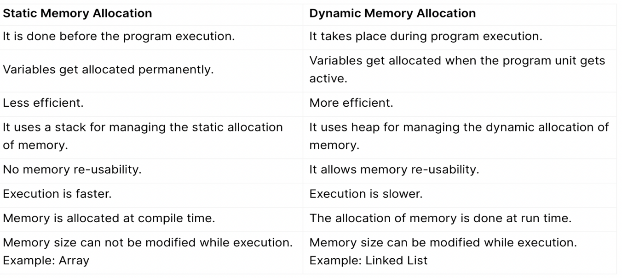

Q56. What do you mean by a memory leak in C?
Ans. A memory leak is a kind of resource leak that happens when programmers create a memory in heap and forget to delete it. Thus, the memory which is no longer needed remains undeleted. It may also occur when an object is inaccessible by running code but it is still stored in memory. A memory leak can result in additional memory usage and can affect the performance of a program.

Q57. What do you understand by while(0) and while(1)?
Ans. In while(1) and while(0), 1 means TRUE or ON and 0 means FALSE or OFF.
while(0) means that the looping conditions will always be false and the code inside the while loop will not be executed. On the other hand, while(1) is an infinite loop. It runs continuously until it comes across a break statement mentioned explicitly.

Q58. Explain the difference between prefix increment and postfix increment.
Ans. Both prefix increment and postfix increment do what their syntax implies, i.e. increment the variable by 1.
The prefix increment increments the value of the variable before the program execution and returns the value of a variable after it has been incremented. The postfix increment, on the other hand, increments the value of the variable after the program execution and returns the value of a variable before it has been incremented.
- ++a <- Prefix increment
- a++ <- Postfix increment

Q59. What is the difference between a null pointer and a void pointer?
Ans. A null pointer is one that does not point to any valid location and its value isn’t known at the time of declaration.
Syntax: <data type> *<variable name> = NULL;
On the other hand, void pointers are generic pointers that do not have any data type associated with them. They can contain the address of any type of variable. Void pointers can point to any data type.
Syntax: void *<data type>;

Q60. Explain the difference between Call by Value and Call by Reference?
Ans. Call by Value sends the value of a variable as a parameter to a function. Moreover, the value in the parameter is not affected by the operation that takes place.
Call by Reference, on the other hand, passes the address of the variable, instead of passing the values of variables. In this, values can be affected by the process within the function.

Q61. How can the scope of a global symbol be resolved in C?
Ans. The scope of a global symbol can be resolved by using the extern storage, which extends the visibility or scope of variables and functions. Since C functions are visible throughout the program by default, you don’t need to use it with function declaration or definition.

Q62. What is the difference between actual parameters and formal parameters?
Ans. The differences between actual parameters and formal parameters are:
Actual Parameters | Formal Parameters
They are included at the time of function call. | They are included at the time of the definition of the function.
Actual Parameters do not require data type but the data type should match with the corresponding data type of formal parameters. | Data types need to be mentioned.
These can be variables, expressions, and constant without data types. | These are variables with their data type.

Q63. Explain modular programming.
Ans. Modular programming is an approach that focuses on dividing an entire program into independent and interchangeable modules or sub-programs, such as functions and modules for achieving the desired functionality. It separates the functionality in such a manner that each sub-program contains everything necessary to execute just one aspect of the desired functionality.

Q64. What is a sequential access file?
Ans. As the name suggests, a sequential access file is used to store files sequentially, i.e. one data is placed into one file after another. It means that if you have to access files you will have to check each file sequentially (reading one data at a time) until your desired file is reached. It is more limitations as access time will be very high and storage cost is high.

Q65. What is the difference between const char* p and char const* p?
Ans. const char* p is a pointer to a constant character whereas char const* p is a constant pointer to a non-constant character. In const char* p, we cannot change the value pointed by ptr. However, we can the pointer. In char *const ptr, we cannot change the pointer p. However, the value pointed by ptr can be changed.

Q66. Can we use the ‘if’ function to compare strings?
Ans. No, we cannot use the ‘if’ function to compare two strings. The ‘if’ function compares numerical and single character values. We can use the ‘strcmp’ function to compare two strings character by character.

Q67. What is the use of toupper() function in C?
Ans. The toupper() function in C converts the lowercase alphabet to uppercase. We define the toupper() function using the ctype.h header file.
Syntax:
int toupper(int ch);

Q68. Explain the newline escape sequence.
Ans. the newline escape sequence denoted by \n is used to insert a newline character into a string.

Q69. Explain the # pragma directive in C.
Ans. # pragma is a special purpose directive that is used to turn on or off certain features. Some of the #pragma directives are:
- #pragma startup: It is used to specify the functions that are needed to run before the program starts.
- #pragma exit: It is used to specify the functions that are needed to run just before program exit.
- #pragma warn: It is used to hide the warning messages which are displayed during compilation.
- #pragma GCC poison: This directive is used to remove an identifier completely from the program.
- #pragma GCC dependency: This directive allows you to check the relative dates of the current file and another file.
- #pragma once: It allows the current source file to be included only once in a single compilation.

Q70. What is variable initialization in C Programming?
Ans. Variable initialization refers to the process of assigning a value to the variable before it is used in the program. Using variables without initialization can result in unexpected outputs. There are two types of variable initialization:
- Static Initialization: variable is assigned a value in advance and it acts as a constant.
- Dynamic Initialization: variable is assigned a value at run time and can be altered every time the program is being run.
Syntax of the variable initialization:
data_type variable_name=constant/literal/expression;
or
variable_name=constant/literal/expression;

Q71. What is the difference between Source Code and Object Code?

Ans. The differences between source code and object code are:

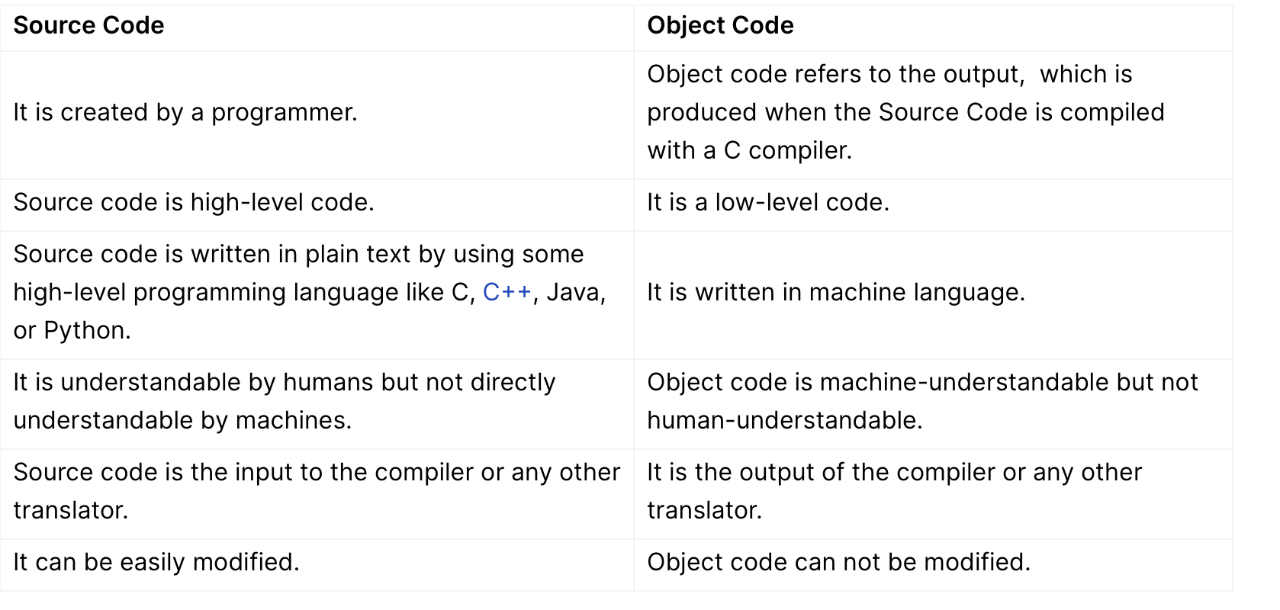

Q72. In C programming, how can you determine if a number is odd or even?
Ans. In C programming, we can determine if a number is even or odd by dividing it by 2. If the number is exactly divisible by 2 (the remainder is 0) then it is an even number else it is odd.
Program to check if a number is even or odd using Bitwise Operator:
#include < stdio.h >
int main() {
int num;
printf(“Enter an integer: “);
scanf(“%d”, &num);
// true if num is perfectly divisible by 2
if(num % 2 == 0)
printf(“%d is even.”, num);
else
printf(“%d is odd.”, num);
return 0;
}
Copy code
Output:
Enter an integer: 77
77 is odd.
Check Out the Best Online Courses

Q73. Write a program to swap two numbers without the use of the third variable.
Ans. We can swap two numbers without the use of the third variable by two methods:

Method 1: Using sum and subtraction
#include < stdio.h >
int main()
{
int a=10, b=20;
printf(“Before swap a=%d b=%d”,a,b);
a=a+b;//a=30 (10+20)
b=a-b;//b=10 (30-20)
a=a-b;//a=20 (30-10)
printf(“\nAfter swap a=%d b=%d”,a,b);
return 0;
}
Copy code

Method 2: Using multiplication and division
#include < stdio.h >
#include < stdlib.h >
int main()
{
int a=10, b=20;
printf(“Before swap a=%d b=%d”,a,b);
a=a*b;//a=200 (10*20)
b=a/b;//b=10 (200/20)
a=a/b;//a=20 (200/10)
system

- Bit swap one side to another side
#include <stdio.h>
unsigned char reverseBits_fast(unsigned char x) {
x = (x & 0xF0) >> 4 | (x & 0x0F) << 4; // swap nibbles
x = (x & 0xCC) >> 2 | (x & 0x33) << 2; // swap pairs
x = (x & 0xAA) >> 1 | (x & 0x55) << 1; // swap single bits
return x;
}

unsigned char reverseBits(unsigned char num) {
unsigned char result = 0;
for (int i = 0; i < 8; i++) {
result = result <<1; // shift left result
result = result | (num & 1); // copy LSB of num
num = num >>1; // shift right num
}
return result;
}
int main() {
unsigned char x = 0b11010010; // 0xD2
unsigned char y = reverseBits(x);
printf("Original: 0x%X, Reversed: 0x%X\n", x, y);
return 0;
}

